STUDY HALL
CLASS VII
SCIENCE- FLOW OF HEAT
WORKSHEET- 2

- Multiple choice questions: Choose the most appropriate answer.

- Conduction takes place
- Solids only c) Gases only
- Liquids only d) In solids, liquids and gases

- Which of these is the best conductor of heat
- Iron c) Water
- Nitrogen d) Alcohol

- Which of these is the best insulator of heat
- Iron c) Water
- Nitrogen d) Alcohol

- Ice slabs are covered with jute or sawdust to prevent them from
- Melting from conduction
- Coming in contact with surface
- Melting due to Heat Release
- Going dirty

- Necessary conditions for conduction to take place are
- Temperature or Contact
- Temperature and Contact
- Temperature Difference and Contact
- Temperature Difference or Contact

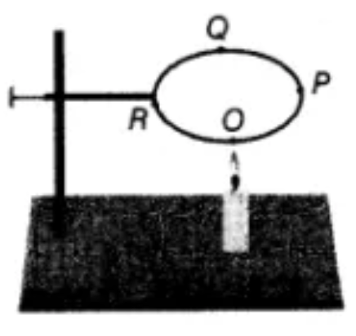
- A circular metal loop is heated at point O as shown in the figure.

- In which Direction, would the heat flow in the loop – O to P / P to O?

- In which order, the pins at points P,Q and R fixed with the help of wax fall if points O, P,Q and R are equidistant from each other?
ACTIVITY
CHECK THE PICTURE BELOW AND TRY PERFORMING IT AT YOUR HOME AND FILL UP THE CHART BELOW WITH YOUR OBSERVATIONS
WHAT DO YOU NEED TO DO?
TAKE A PENCIL, A PEN AND A SPOON.
STICK A LITTLE PIECE OF BUTTER/ WASTE CANDLE OVER EACH.
PLACE THE THREE IN GLASS AS SHOWN.
POUR HOT BOILING WATER IN IT.
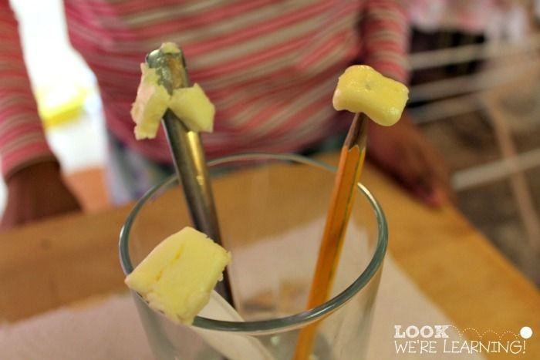
## IF POSSIBLE CLICK A PICTURE OF YOU PERFORMING THESE TWO ACTIVITIES AND ATTACH IT TO THIS WORD FILE ONLY AFTER THE CHART AND SUBMIT.
WHAT DO YOU OBSERVE AND Why?

